ASSIGNMENT - 2

|  |  |
| --- | --- |
| Date | 28 October 2022 |
| Team ID | PNT2022TMID18166 |
| Project Name | Analytics for Hospital Health-Care Data |
| Maximum Marks | 2 Marks |

Challenge:

Upload the dataset to Cognos Analytics, prepare the data, explore and Create Interactive Dashboard.

Task 1: Sales By Customer

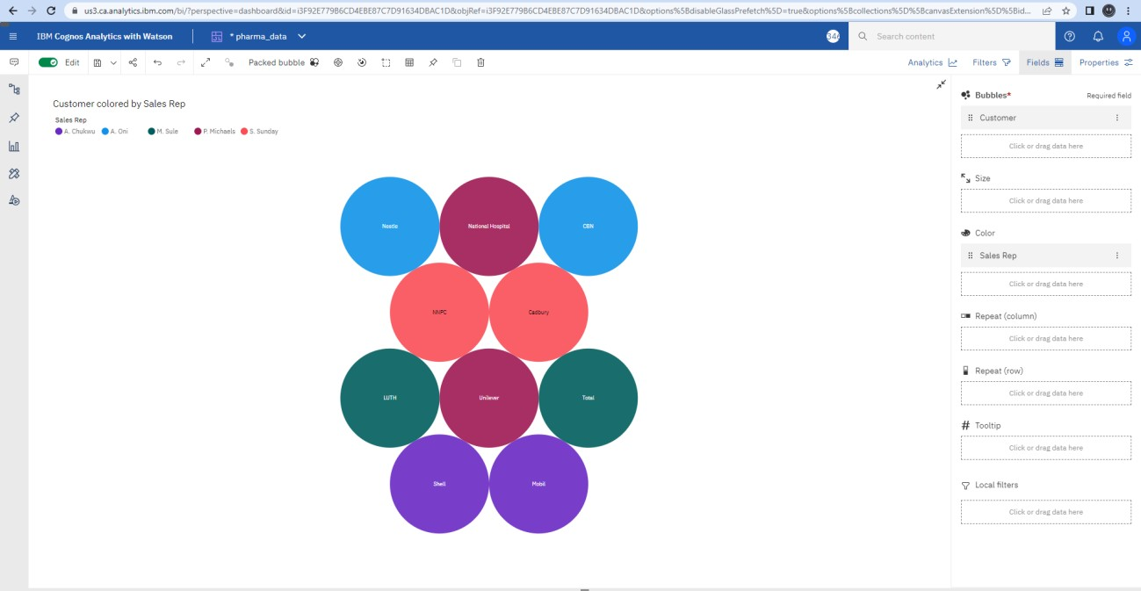

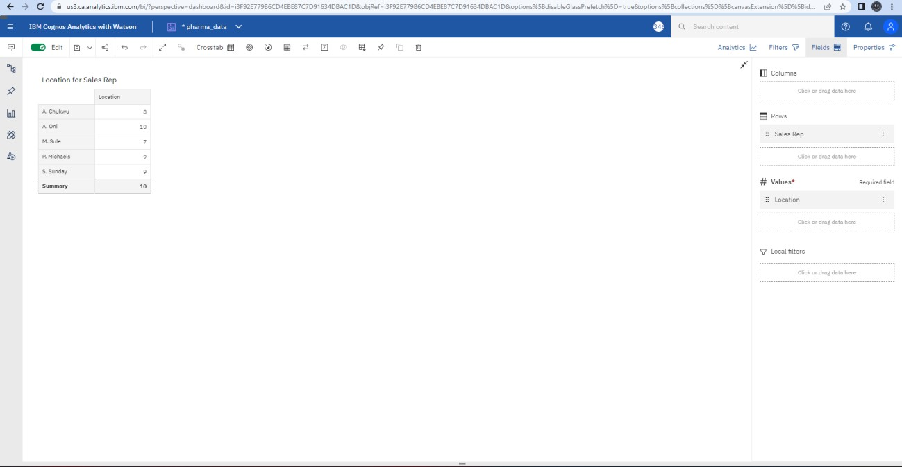

Task 3: Sales By Sales Representative

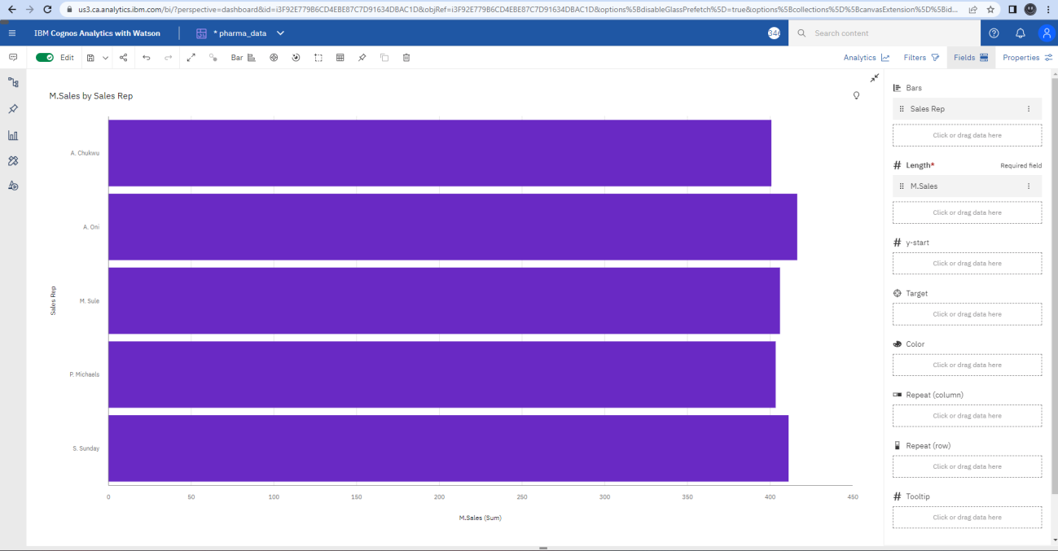

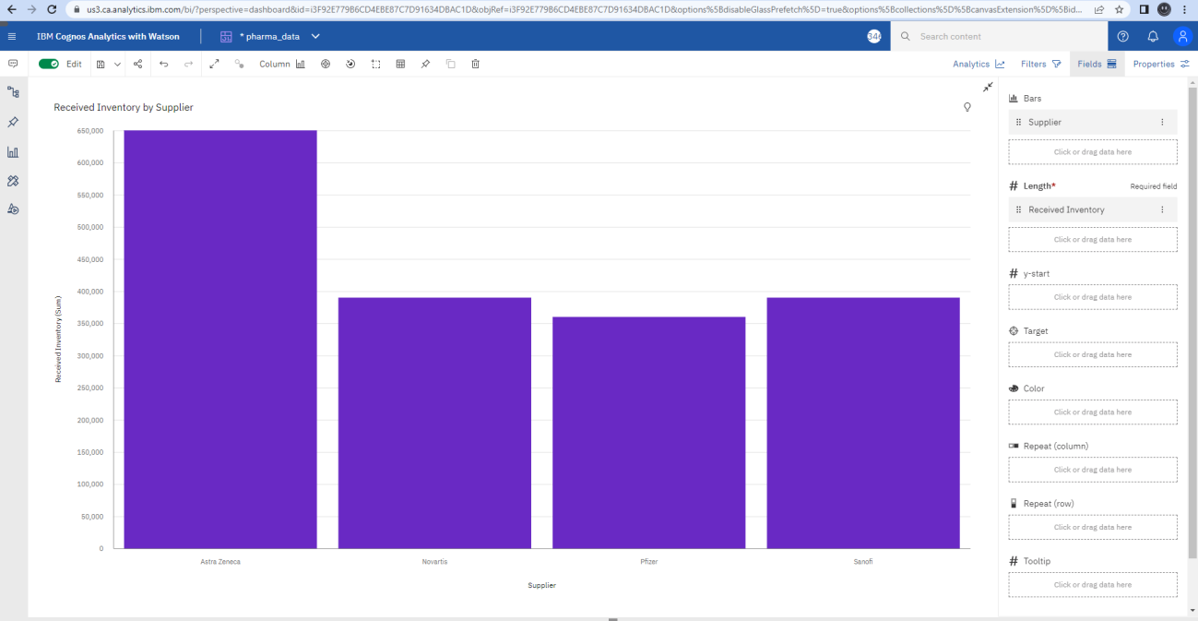

Task 5: Inventory Stock for Warehouse Locations

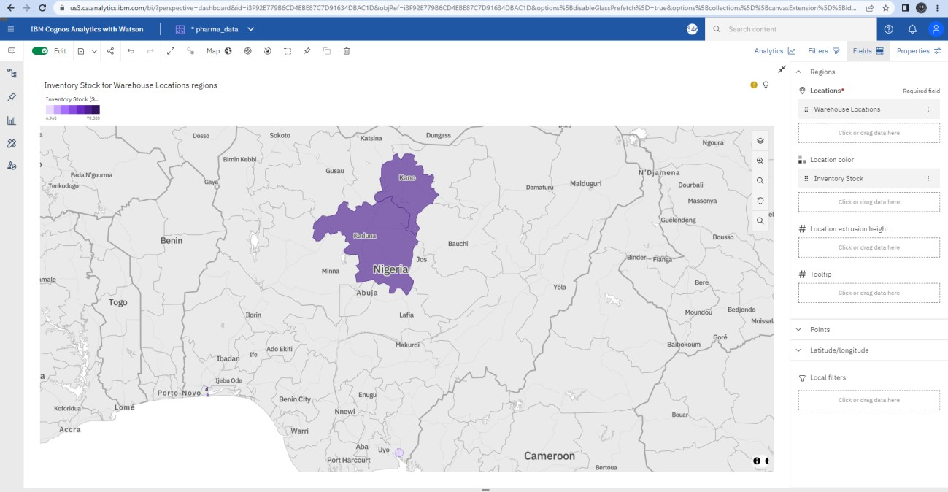

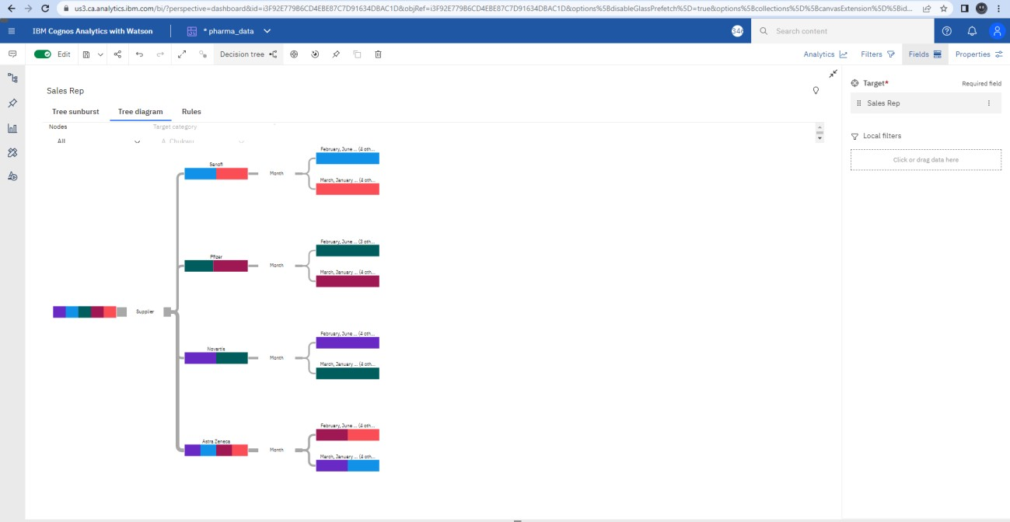

Task 7: Monthly Sales

